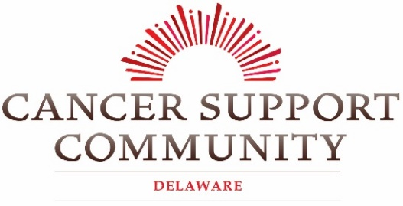

18947 John J. Williams Highway, Suite 312 npickles@cscde.org Rehoboth Beach, DE 19971 (302) 645-9150

Dear Friend,

Cancer Support Community Delaware (CSCDE) is excited to announce the return of one of our most popular events, which always sells out: The Pink Affair. Typically, this event is a lovely luncheon and boutique held in celebration of the cancer journeys of our participants and the partnerships we have built throughout the community. However, due to social distancing mandates, we are going in a new direction for a new time in the world. Just like our in-person programming we have made this event virtual! This unique and memorable event is a perfect opportunity to showcase your business over 6,800 individuals in our email listings and to over 3,000 of our social media followers; s well as your support for CSCDE at one of our largest fundraisers in 2020.

Business sponsorships support CSCDE’s critical work as non-profit organization, providing support services to cancer patients, caregivers, and their families. Our mission is to ensure that all people impacted by cancer are empowered by knowledge, strengthened by action, and sustained by community. We are a support system every step of the way during each individual’s journey with cancer; from diagnosis to treatment, remission, and beyond. Our support groups, educational workshops, and a wide range of programs including Yoga, T’ai Chi, Meditation, Art Therapy, Bereavement, and Nutrition Classes are accessible at no cost to the participant.

On March 18th, CSCDE quickly pivoted from in-person services to virtual programming due to the crisis. We are proud to be able to say that we have continued to provide services to our at-risk cancer community; with ZERO days of missed programming. Over 3,300 people statewide have participated in our weekly virtual programs at no cost to the participant, and we are accepting new registrations daily. However, as our number of Delawareans served since the crisis has surged; so, has our loss of funding.

This important sponsorship will not only allow us to reduce costs of essential pieces of one of our major fundraising events but will enable our supporters to participate in this event at a cost that better reflects the financial realities of families during this time. Please consider supporting CSCDE as an event sponsor! Enclosed you will find the necessary sponsorship forms. Stay up-to-date with event information, register as a sponsor, and more at: www.cancersupportdelaware.org.

Thank you for your consideration, and together we can ensure no one in Sussex County faces cancer alone!

Sincerely,

Cancer Support Community Delaware

Pink Affair
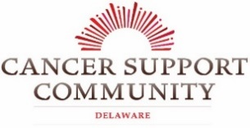
2020 Event Sponsorship

October 30, 2020 at Beebe’s Tunnell Cancer Center
Deadline for Business Sponsorship: October 9, 2020
The Pink Affair is back and with a new direction! We are pleased to announce that we have made this year’s event virtual, with the showcase of some of our wonderful survivorship stories. We have also included a Balloon-gram this year for you to send a happy and supportive email decorated with a pink balloon, or the color of the cancer ribbon that best fits the individual that the message is in honor/memory of. To best adhere to social distancing protocols the Pink Affair boutique and chance auction will be hosted by appointment only this year. This one of kind event has consistently had over 250 women attending in previous years. We hope you will join us for this fun event for an important cause!
*Please note that this event is currently scheduled to occur as planned with adherence to the social distancing mandates. If there are any changes to this event, due to social distancing protocol, we will inform you via email or through our website.

Sponsorship Level | Sponsorship Benefits – Pink Affair 2020
Pink Affair Boutique Sponsor  $2,000+ | As a presenting sponsor of the Pink Affair you will receive all of the benefits included in the Shine Bright like a Diamond Sponsor level, plus additional ways to highlight you/ your company’s support of CSCDE throughout the Pink Affair. We will work together to create the sponsorship package you are most proud of!
Shine Bright like a Diamond  $1,000 | - Name/Company featured prominently on the front of event signage and within the event marketing  - Name/Company featured in all e-blasts  - Name/Company featured in 6 social media posts  - Name/Company listed on event website  - Personalized sponsor recognition placed throughout Survivorship Stories  - 4 Boutique tickets
Fun & Fabulous  $500 | - Name/Company listed on event signage and within the event marketing  - Name/Company featured in all email e-blasts  - Name/Company featured in 2 social media posts  - Name/Company listed on event website  - 2 Boutique tickets
Pretty in Pink  $250 | - Name/Company listed within event program  - Name/Company featured in all email e-blasts  - Name/Company featured in 1 social media post  - Name/Company listed on event website

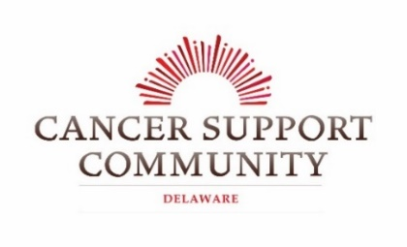
2020 Pink Affair Sponsorship
Deadline: October 9, 2020

Pink Affair

Presenting Sponsor $2,000+

Shine Bright Like a Diamond $1,000

Fun and Fabulous $500

Pretty in Pink $250

Contact Information:
Name/Company (as you would like it to appear in promotional materials):

Your Name: Title:

Address:

City: State:______________ Zip Code:______________________
Phone Number: Email:

Payment Information:
Payment Method: Check MasterCard Visa Amex
Credit Card Number: _____________________________________________________________________________________
Name on Card: _______________________________________________________________________
Exp. Date: ____/____ /____ CVC: ________ Signature: ___________________________________
Make checks payable to Cancer Support Community Delaware.
Your donation is tax-deductible to the fullest extent allowed by law. Tax ID # 51-0351863

Please Email Your Logo To: jsimmons@cscde.org (in high resolution jpeg or png format)

For more information contact our office:
(302) 645-9150
18947 John J. Williams Highway, Suite 312, Rehoboth Beach, DE 19971

